

620574-EPP-1-2020-1-NO-EPPKA3-VET-COVE Erasmus+ Center of Vocational Excellence bridges.eu

D11.5 – Innovation Camps

WP 11 - Implementation VET enhanced regional development, innovation and entrepreneurship.

WP Leader: UNAK

Contributors: GG


The European Commission support for the production of this publication does not constitute endorsement of the contents which reflects the views only of the authors, and the Commission cannot be held responsible for any use which may be made of the information contained therein.

Small scale innovation Camp, Sweden
Gullmarsgymnasiet has designed a small-scale innovation camp so that an aquaculture company can come to the school with a development problem within the company's operations. The students try to come up with new approaches to solve the problem and develop the company.
In order to best help the aquaculture company and give the students the conditions to create new innovations, a form has been created (see appendix 1). A meeting between the school and the company has been conducted to map out what the company needs help with and how the innovation camp can be designed to create added value for both the company and the students.
To develop this concept with an innovation camp, an evaluation sheet for the students (see appendix 2) and for the company (see appendix 3) has also been produced and used as an assessment for future innovation camps.
A small-scale innovation camp was carried out on 26/5-2023 together with the company Volta Greentech and the students from the first year of Aquaculture studies. Volta Greentech is a company that grows a red algae that is given to cows to reduce the methane emission from the livestock by approx. 70%-90%. What the students primarily shood help with was to make a sales pitch for their climate friendly meat to a specific target group that the company should focus on.
Schedule for the innovation camp:
08.30-09.00 The company was presented and what they need help with from the students.
09.00-09.30 The students worked in groups and thought about how to solve the problem.
09.30-11.30 The students created a presentation to solve the problem.
12.30-13.30 The students present their proposals to the company. A winner was presented by representatives of the company.
13.30-13.40 The students and company evaluated the innovation camp.

Pictures from the innovation camp:

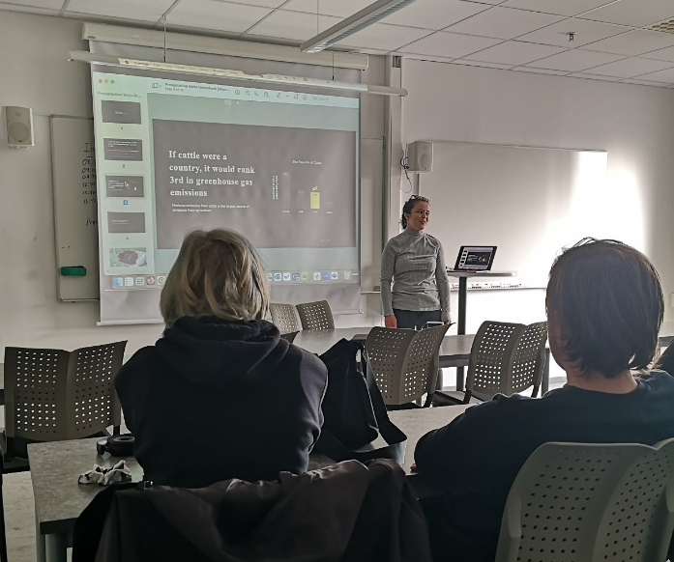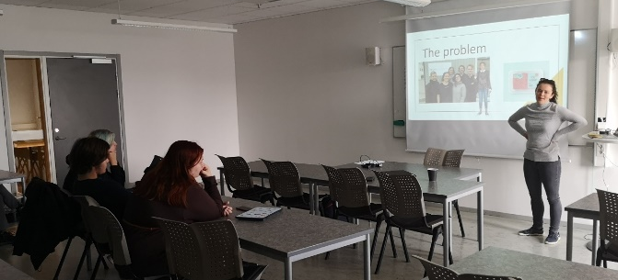
Fig 1 and 2: Cora Taylor Factory Manager from Volta Greentech precent and describe what the company need help with.

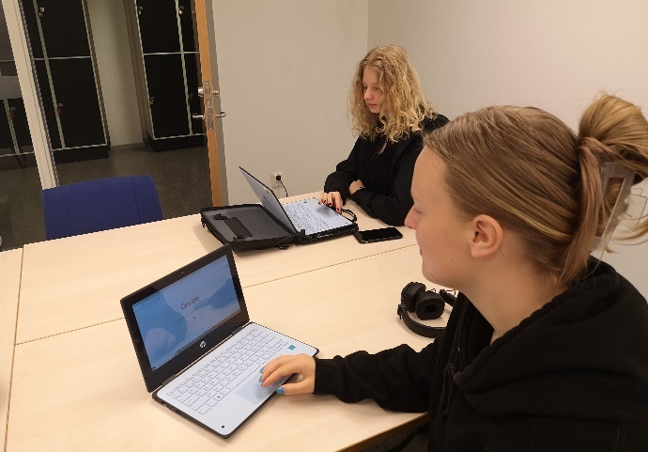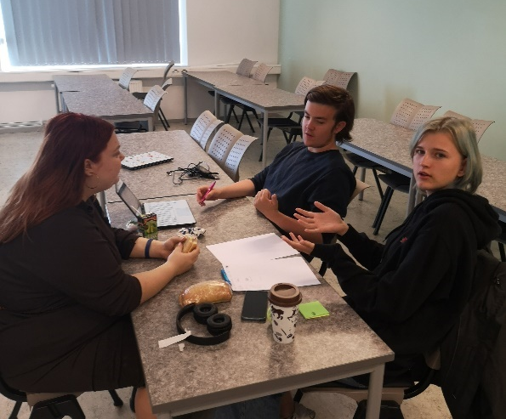

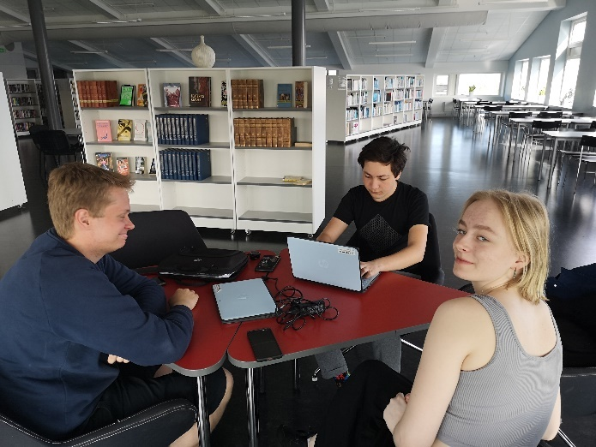
Fig 3, 4 and 5. Students working in groups with new innovations for the company.
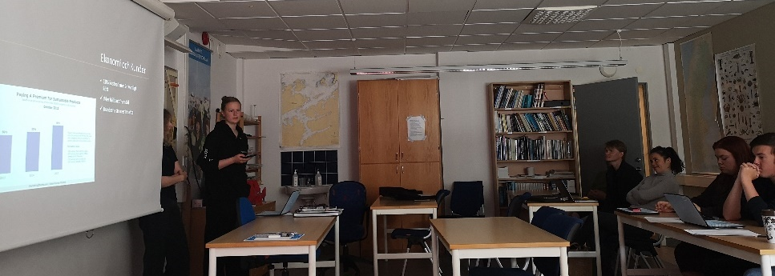
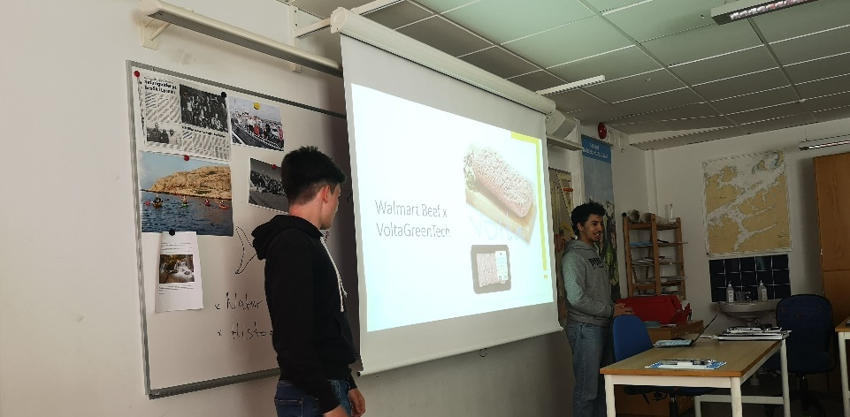
Fig 6 and 7. The students presents the innovation to three representatives for Volta Greentech.

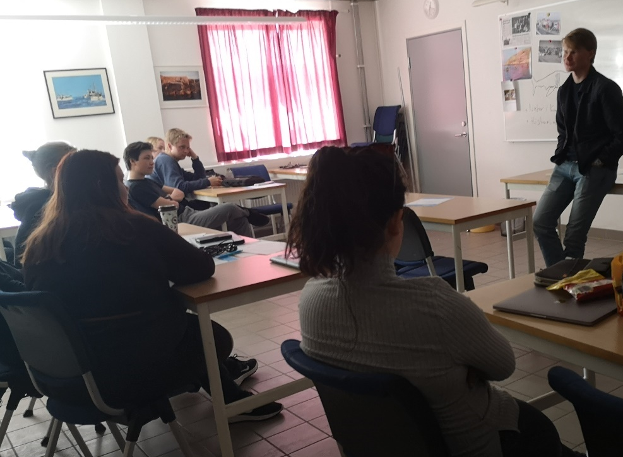

Fig 8. Fredrik Åkermanz, Founder & CEO at Volta Greentech thanks the students and talk about the Companys future.

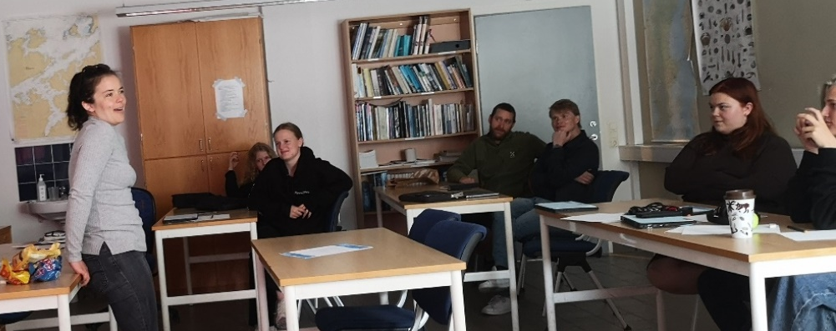
Fig 9. Cora Taylor precented the winners for the most innovative presentation.

Evaluation of the innovation camp:

COPYRIGHT
©Copyright 2020-2024 the Bridges Consortium, consisting of:
- Trøndelag County Authority (TC), Norway
- Gullmarsgymnasiet/Lysekils Vuxenutbildning (GG), Sweden
- Peimari Group for Further Education and Training (Livia), Finland
- Icelandic College of Fisheries (ICF), Iceland
- Holar University (Holar), Iceland
- University of Akureyri (Akureyri), Iceland
- SalMar Farming (Salmar), Norway
- Arnarlax (Arnarlax), Iceland
- Nordic Trout (NT), Finland
- Nordic Trout Sweden (NTS), Sweden
- Blue Competence Centre (BCC), Norway
- Easy Learning Solutions (ELS), Norway

This document may not be copied, reproduced or modified in whole or in part for any purpose without written permission from the Bridges Consortium. In addition to such written permission to copy, reproduce or modify this document in whole or part, an acknowledgement from the authors of the document and all applicable portions of the copyright notice must be clearly referenced.
All rights reserved.
This document may be updated if needed and changed without notice.


Contact: Dag Willmann
dagwi@trondelagfylke.no

